Temasek Polytechnic
School of Informatics and IT

Diploma in Information Technology (IT)

Project Plan

Project Particulars

Tutor | Mr Goh Mya Hu, Mel
Class | P01
Project Title | Delonix Regia Hotel Management System

Project Team’s Particulars

Matric Number | Student Name
1505544E | Susmitha D/O Appalanaidu
1400777G | Lee Yi De Jasper
1505449G | Claudia Yeo Jun Bing

Table of Contents

- Introduction
  - Objectives and scope of the project
  - Assumptions and constraints
  - Definitions and acronyms

- Roles and responsibilities

- Estimates and project schedule
  - Work breakdown structure
  - Project schedule
  - Budget summary

- Risk management plan
Project Plan

1 Introduction

  - Objectives and scope of the project

The objective of this project is to ensure customers are able to book hotel rooms without errors or conflicts as well as providing them with the most accurate hotel room information of available accommodations. It is to make sure that the status of reservation is always up to date, allowing ease of information for customers when selecting a hotel to stay in. However, implementing a good hotel management system is just not enough, security is equally essential too. It is to prevent unauthorized users from entering the system and making sure that all confidential information are kept safe. Lastly, we want to provide customers with a user-friendly system so that they can get a pleasant experience in making reservation, presenting them with the best hotel targeted to them at the same time.

The scope of the project are as follows.
Security - Ensuring any confidential information or data will be secure and prevent any authorized users from hijacking,

User-friendly interface - Having a user-friendly system and functions allows customers to have a pleasant experience in surfing the features in the web page easily without any complications.

Generate automate email - An email will be sent to customers/guest regarding their bookings for confirmation.

  - Assumptions and constraints

Assumptions

- Specifications: Our client or the project specifications will be clear with little to no changes, unless defined or found by us during the development forcing a change. A sign will be required before we develop the project.
- Methodology: We would use a programming language we are all together most comfortable, optimal and familiar with.
- Data Conversion: Not included. Will only use sample data for testing, but no conversion of any data.
- User Acceptance Testing: The client will give appropriate support to assist in preparation of the Acceptance Test.
- Environment: The necessary equipment such as the hardware and software as well as the environment we are to work our project will be ready.
Constraints

- Business: Budget, time and resources.
- Technical: limits design choices depending on the specification

1.3 Definitions and acronyms

Team consists of 3 members: Susmitha, Claudia and Jasper.
Terms of Reference (TOR)

- Roles and responsibilities

Feature 1 (Susmitha D/O Appalanaidu): Booking ballroom

Description: The booking ballroom feature will enable customers to book a ballroom in advance. The information that will be required will be the customer’s personal details and contact information, the event type, event name, event description, event date and time, the number of guests that will be expected and the number of tables required. The system must be able to create the booking, retrieve the booking, update the booking if any changes are made and delete the booking if the customer cancels the booking.

Feature 2 (Claudia Yeo Jun Bing): Search Availability

Description: It is a feature where it holds a record of the availability of hotel rooms and guests are allowed and able to search for the availability of a hotel room to stay in.

Feature 3 (Lee Yi De Jasper): Restaurant Booking

Description: Another feature which holds records of restaurant bookings and their availability to the public and hotel guests. Customers can check and book/reserve time slots for the restaurants.

- Estimates and project schedule

3.1 Work breakdown structure

1. Software Requirements Engineering
1.1. Develop Terms of Reference (TOR)
1.1.1. Identifying objectives and scope
1.1.2. Evaluating constraints
1.1.3. Evaluating resources
1.1.4. Identifying approach to use
1.1.5. Developing Project Plan
1.1.6. Determining budget
1.1.7. Determining risk management plan
1.2. Discussion with clients
1.2.1. Conducting interview
1.2.2. Brainstorming sessions
1.2.3. Finalize requirements
1.2.4 Sign off

2. Analyzing and designing features
2.1. Booking ballroom feature
2.1.1. Analyzing requirements for booking feature
2.1.2. Creating a draft design of the booking system
2.1.3. Creating a draft prototype
2.1.4. Gathering feedback for draft booking ballroom feature
2.1.5. Analyzing the feedbacks
2.1.6. Creating final booking ballroom feature design
2.1.7. Creating final booking ballroom feature prototype
2.2. Search Availability feature
2.2.1. Analyzing specifications for searching feature
2.2.2. Creating a draft design of searching feature
2.2.3. Creating draft prototype
2.2.4. Collecting and analyzing feedback/suggestions
2.2.5. Creating searching feature final design
2.2.6. Creating searching feature final prototype

2.3. Restaurant booking feature
2.3.1 Analyzing requirements for restaurant booking feature
2.3.2 Creating draft design of restaurant booking feature
2.3.3 Creating draft prototype
2.3.4 Testing prototype and collecting feedback
2.3.5 Analyzing feedback
2.3.6 Creating final design of restaurant booking feature
2.3.7 Creating final prototype of restaurant booking feature
3. Implementation
3.1. Booking ballroom feature
3.1.1. Preparing for implementation
3.1.2. Converting data
3.1.3. Starting to code
3.1.4. Monitoring the system
3.1.5. Debugging the system
3.1.6. Configuring the system
3.1.7. Installing payment software
3.1.8. Installing security software
3.2. Searching availability feature
3.2.1. Implementation preparation
3.2.2. Data conversion
3.2.3. Implementing codes
3.2.4. Monitoring and debugging system
3.2.5. Configuring system
3.2.6. Installing security software
3.3. Restaurant booking feature
3.3.1 Implementation preparation
3.3.2 Data converting
3.3.3 Implementing codes
3.3.4 Testing, monitoring and debugging codes
3.3.5 Configuring system
3.3.6 Setting up security software

4. Testing and deploying
4.1. Booking ballroom feature
4.1.1. Creating a test plan
4.1.2. Conducting testing
4.1.2.1. Test if bookings can be made successfully
4.1.2.2. Test if the bookings are saved in the database
4.1.2.3. Test if the booking details can be retrieved
4.1.2.4. Test if the booking updates the availability of the ballrooms
4.1.3. Collect results and document
4.1.4. Deploying
4.1.4.1. Deploying the booking ballroom feature
4.1.4.2. Gaining acceptance of the feature
4.1.4.3. Training the clients on how to handle the feature
4.1.4.4. Conducting signing off
4.2. Search availability feature
4.2.1. Creating test plan
4.2.2. Conducting testing
4.2.2.1. Testing of search feature if it is working successfully
4.2.2.2. Test if the availability of rooms is saved in database
4.2.2.3. Test if availability of rooms can be retrieved
4.2.3. Collection results and documenting
4.2.4. Deploying
4.2.4.1. Deploy search availability feature
4.2.4.2. Gain acceptance of feature
4.2.4.3. Train clients in handling feature
4.2.4.4. Conducting sign off
4.3. Restaurant Booking feature
4.3.1. Creating test plan
4.3.2. Conducting testing
4.3.2.1. Testing of restaurant booking feature if it is working successfully
4.3.2.2. Test if the availability of restaurants is saved in database
4.3.2.3. Test if availability of restaurants can be retrieved
4.3.3. Collecting results and final analysis
4.3.4. Deploying
4.3.4.1. Deploy restaurant booking feature
4.3.4.2. Gain acceptance of the feature
4.3.4.3. Train and teach clients of the new feature
4.3.4.4. Conduct sign off

3.2 Project Schedule

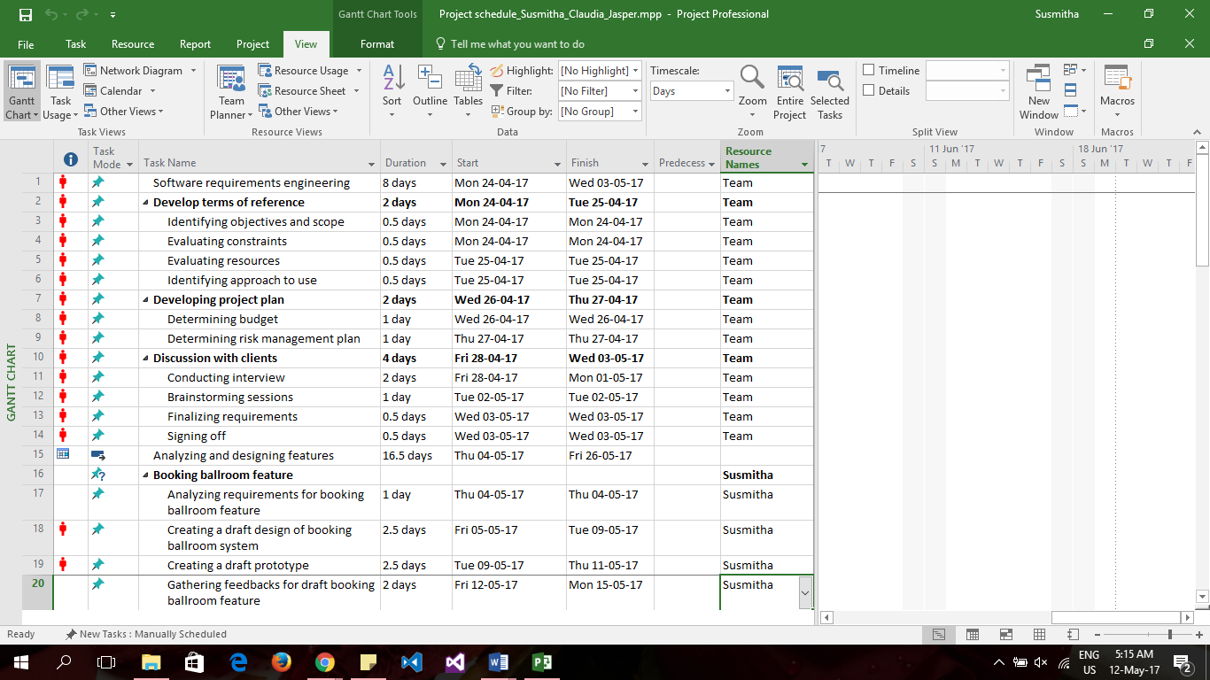

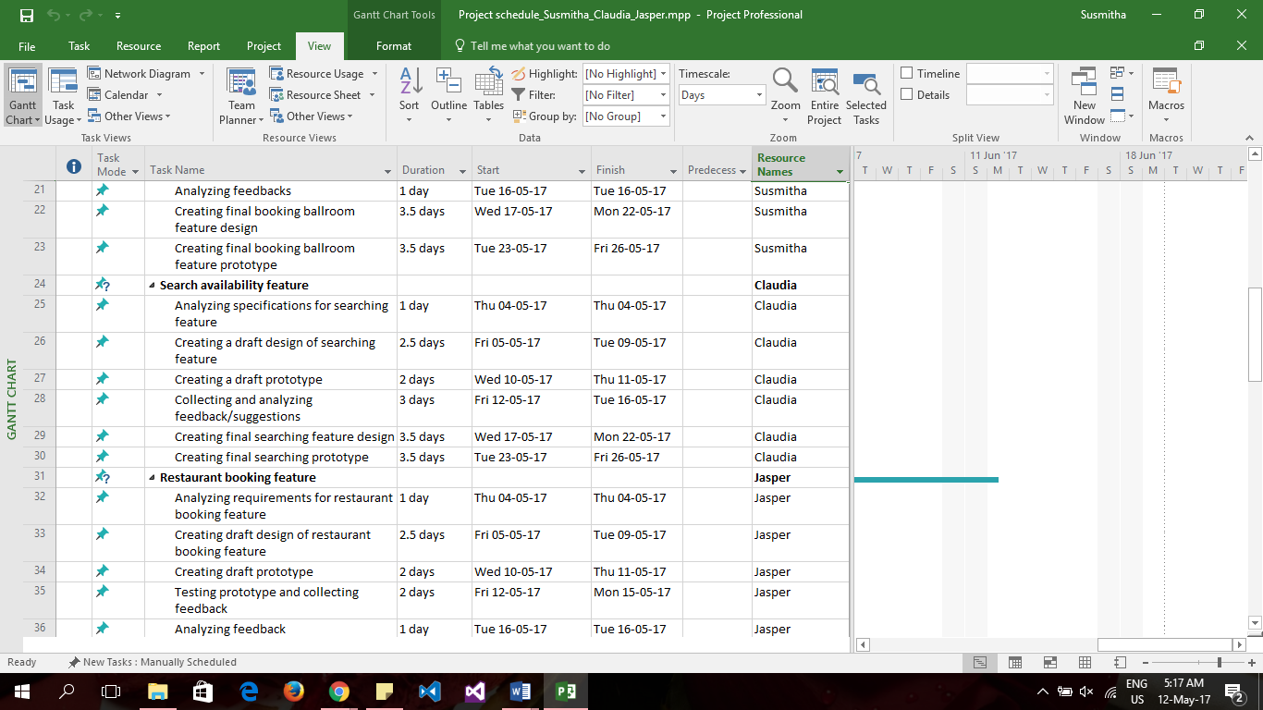

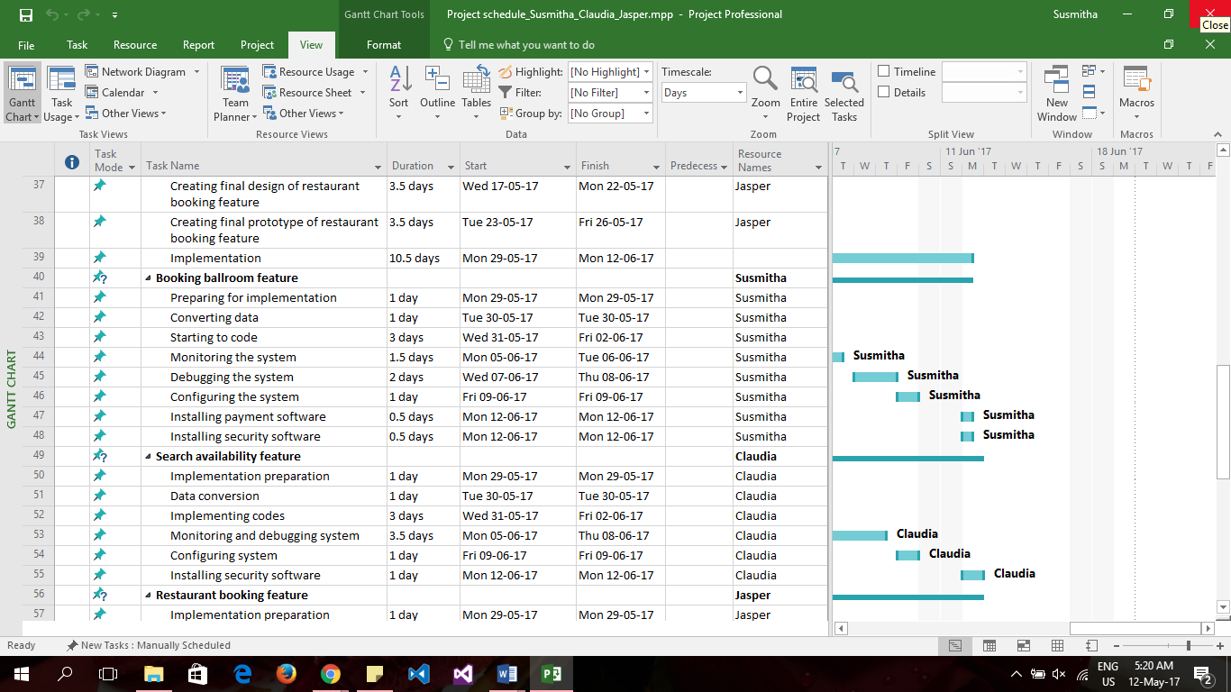

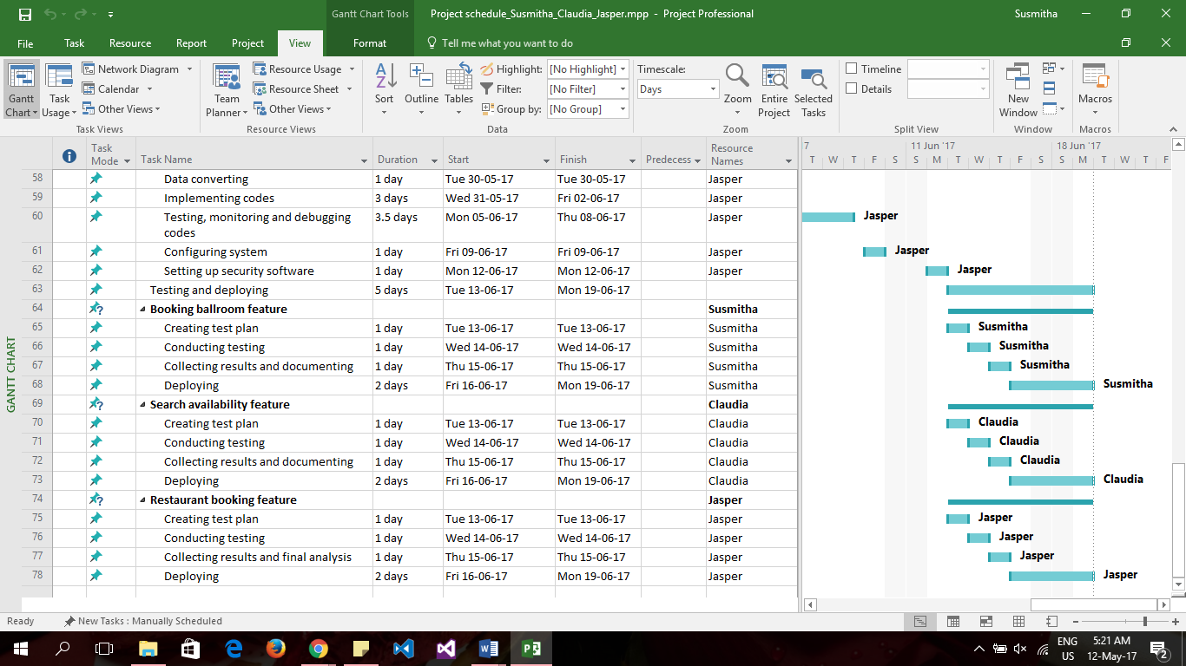

3.3 Budget Summary

Item | Amount ($)
Software | $18,349
  Antivirus | $1,190
  Anti-spam | $2,160
  Operating System | $12,000
  MSDN | $2,999
Hardware | $42,999
  Computer (100) | $42,999
Manpower | $216,692
  Senior Software Engineer | $80,920
  Software Engineer | $72,448
  Programmer Analyst | $63,324
Online Services | $8,600
  Cloud service | $5,600
  Web Hosting | $3,000
Miscellaneous | $50,000
TOTAL | $336,640

- Risk Management Plan

Category | Description | Occurrence chance | Severity
Project | Personnel resign (leaves project for any reason) | low | high
Project | Schedule too short | medium | medium
Technical | Poor maintenance of the project leading to unstable software | low | medium
Business | Building a software that probably already exists (competitor) | medium | high
Business | Sudden fund or budget cut | low | high

Distribution of Workload

Objectives/Deliverables | Members
Objectives and scope | Claudia Yeo Jun Bing
Assumptions and constraints | Lee Yi De Jasper
Definitions and acronyms | Susmitha D/O Appalanaidu
Roles and responsibilities | Lee Yi De Jasper,  Susmitha D/O Appalanaidu,  Claudia Yeo Jun Bing
Work Breakdown Structure | Lee Yi De Jasper,  Susmitha D/O Appalanaidu,  Claudia Yeo Jun Bing
Project Schedule | Susmitha D/O Appalanaidu
Budget Summary | Claudia Yeo Jun Bing
Risk Management Plan | Lee Yi De Jasper

References

Claudia

http://www.theprojectdiva.com/application-development-project-work-breakdown-structure/

Jasper

http://it.toolbox.com/blogs/enterprise-solutions/lists-of-assumptions-constraints-with-a-sample-26073
http://www.brighthubpm.com/risk-management/5141-risk-management-plan-examples/

